1. we will be going to use the snells formula but we will be going to use the refractive index of water and this time the light will speed up causing it to bend away fom the normal.
Things under water will look more closer to the surface than they are because the light from the object reflect away from the normal at the surface. light rays appera to bed as a result of slowing down of light wave entering the water.
2.
a. The ray helps us to investigate the behaviour of light since the light ray inthe air is closer than the light ray in water,the same case applies to the wave.
b. the speed to which the light rays travel changes or gets obstracted thus refraction of light taking place and some of it getting reflected.
c. The light will not move at a high speed as compared to air so therefore refraction will not be a very big angle as compared to that of water.
d.Nothing big will change because both air and glass are more denser than air so reflection and refraction will take place but in glass the angle of refraction will be big.
e. Testing refractive index of different materials.
f.When light travels from one medium to onethor it will go through a phenomenon known as refraction.
The angle at which the ray is entering the medium is known as incident angle while it leaves the medium is known as refracted angle.
all light will undergo refraction some will be reflected bck at the normal creating an angle known as rereflected angle while the internal angle is the relation between incident angle to the refracted angle.
3.
a. The angle of refraction changes slightly as the wavelenght changes from 380nm to 780nm by a margin of 0.1 degrees.
This shows that as the wavelength increaces there is an increase in speed for light ie speed of light is directly proportional to the wavelenght thus resulting to slightly high refraction angle.
The angle of incident choosen is 80 degrees so that the angle of refraction not to be big.because at a particular angle no refraction will take place.
b. The higher the speed of light the greator the refraction of light its.
An increase in speed accerelates more particles to pass through the medium thus being refracted. An increase in speed is directly proportional to increase in refracted angle.
c. The colour does not change.Both in refraction and reflection.
4.Difference glasses have different angles of refraction.the more a glass is symentry or irrugalar in shape the greator the angle of refraction. Refraction of a glass is highly affected by the shape of the glass.
Another thing is at different positions of a glass which is uniform the angle of refraction is differnnt.
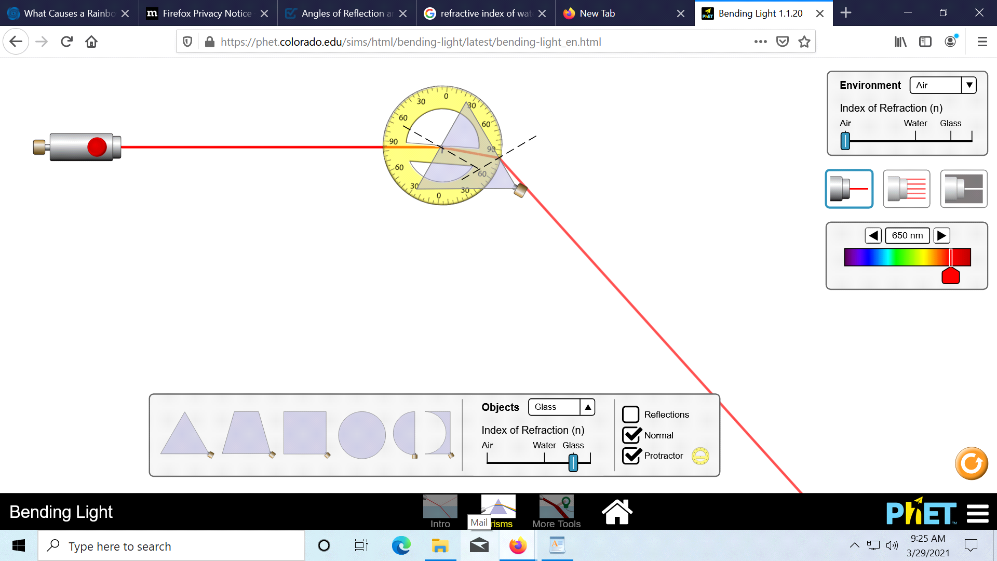
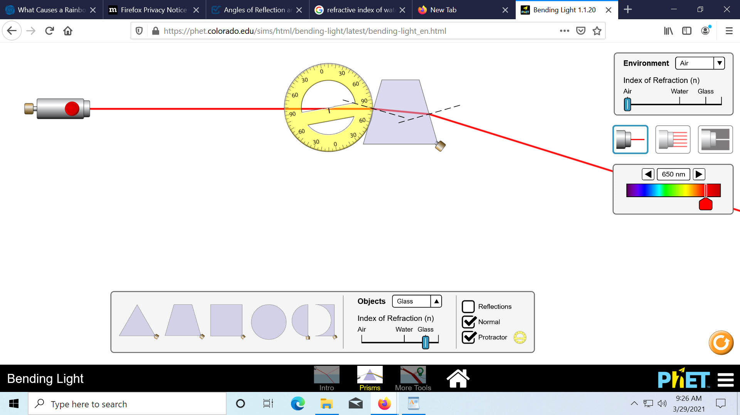
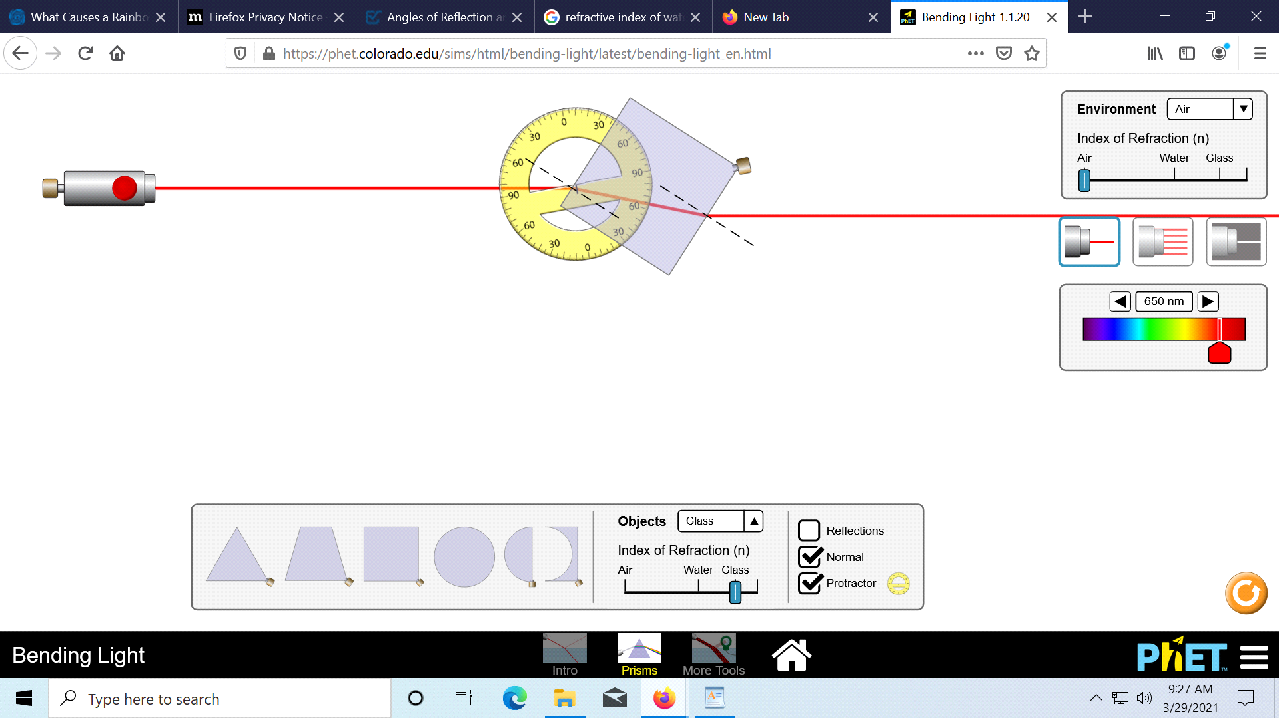

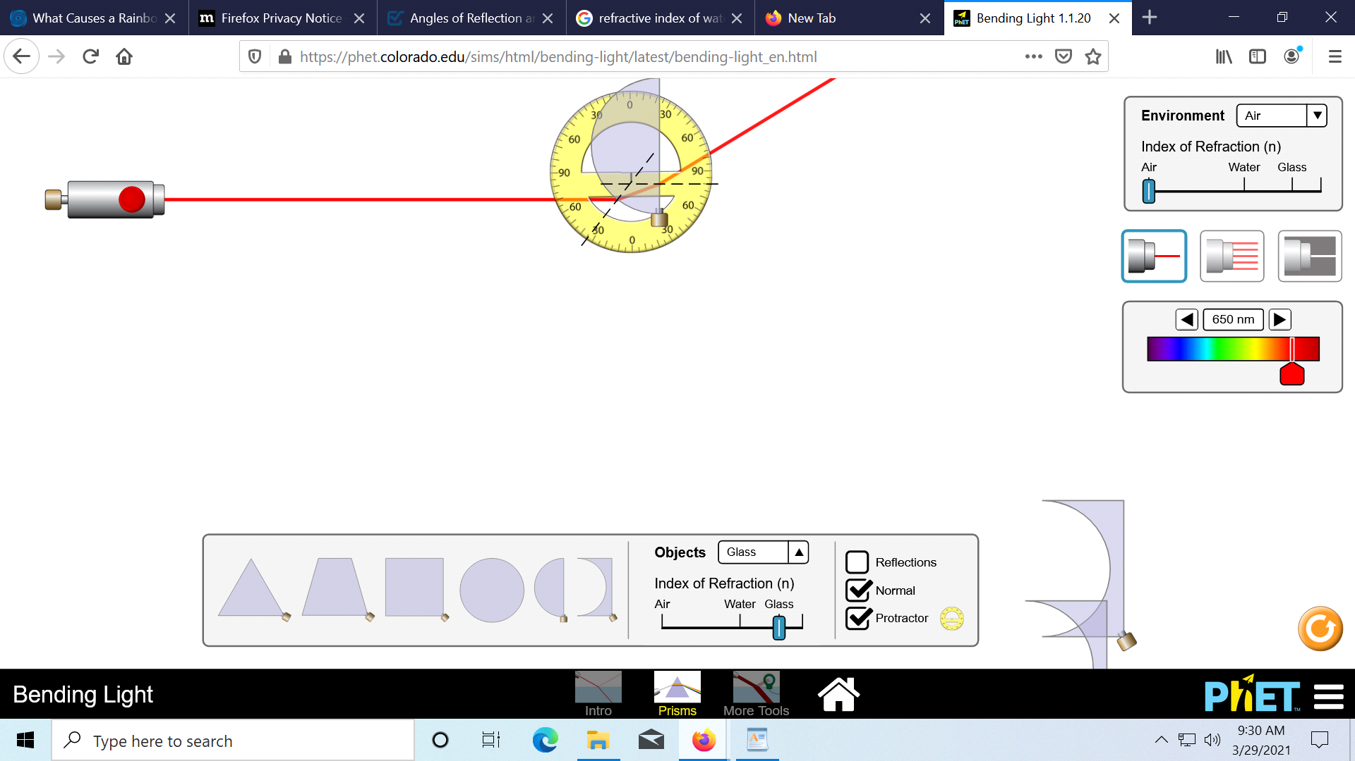

5.A rainbow is formed when light enters into the prism slowing down and bending as it goes from air to dense prism. The light reflects of the inside of the droplets separating into colours.ie rainbow is a spectrum of many colors.
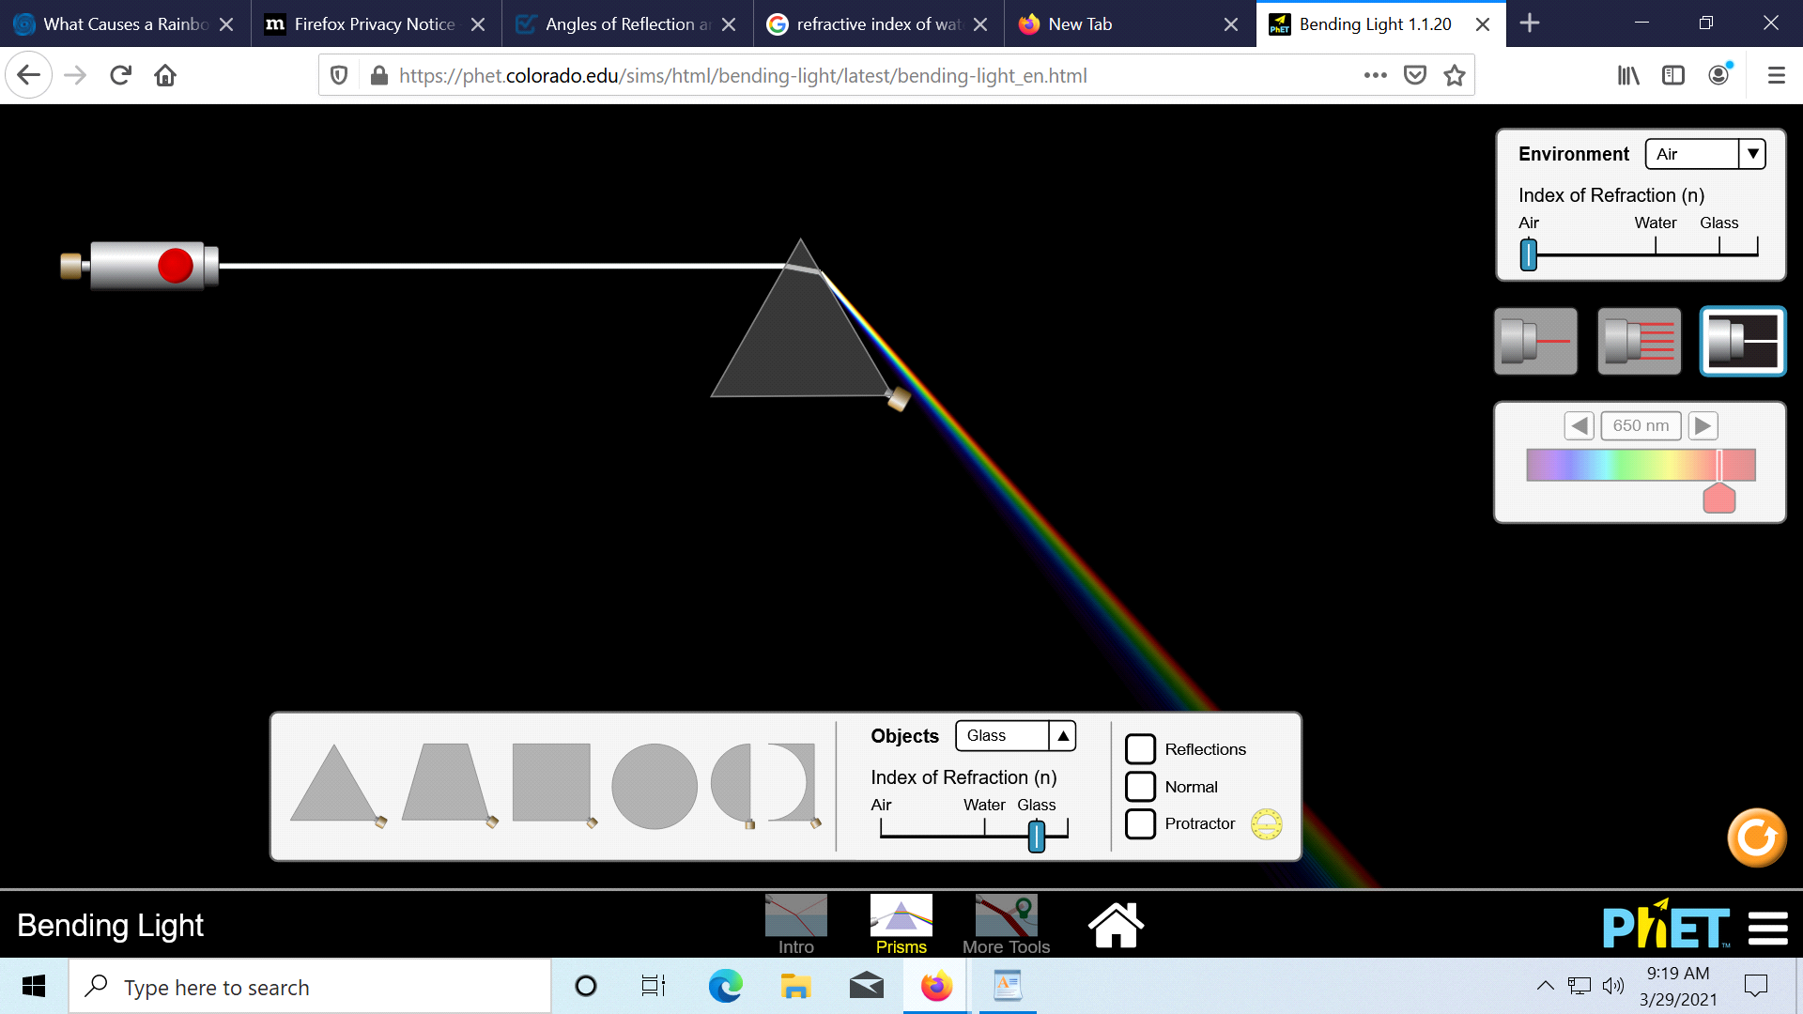

b. because some colors are not made of continous band of different color.ie white color is made up of continous band of different colours that why it produces rainbow.
6.a. 1.00sin30=1.33sinx
sinx=22.08degrees
angle of reflection is 30 degrees
b.1.33sin30=1.00sinx
sin x=41.68degrees
angle of reflection is 30 degrees
c. 1.00sin30=1.57sinx
sinx=18.57degrees.
angle of reflection is 30degrees
d.. 1.33sin30=1.57sinx
Sinx=25.0°
e..1.00sin30=1.22sinx.
Sinx=0.5÷1.22
Sin X =24.2
Angle of reflection is 30°
Ie. angle incidence is equal angle of reflection.

